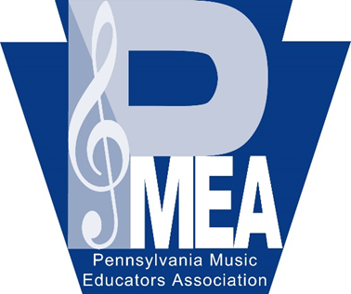
PMEA District 10
Elementary Song Fest
Palmerton Area School District
March 14, 2023

Dear Music Educators,

It is our pleasure to host the PMEA District 10 Elementary Song Fest on March 14, 2023 with an inclement weather date of March 16, 2023, at Palmerton High School. This festival is open to fifth and sixth grade students under your direction. Mrs. Kelly Rocchi, from Nazareth Area High School, will serve as our guest conductor.

The festival will begin at 11:30 a.m. with the concert being held at 7:00 p.m. Directors are
required to accompany their students to the festival. All participating directors MUST BE
MEMBERS OF PMEA. Please include a photocopy or digital copy of your membership card with
your registration.

You may nominate up to 12 students for the festival. We are anticipating a chorus of
approximately 110 students. With the combination of the North and South Song Fest, the number of students selected from each school will depend on how many schools nominate students. We hope to see as many as possible participate. Remember students must be in fifth or sixth grade. A registration fee of $42.00 is required for each student to participate. This fee will cover the cost of the music, the guest conductor, accompanist, etc.

The link to the online registration form can be found on the District 10 website. Please
complete the registration by December 10, 2022. You will receive final confirmation of the
number of students selected to participate by email. At that time, we will ask you to send in
the registration fees and paperwork.

We look forward to working with you and your students. If you have any questions, please do not hesitate to get in touch with us.

Sincerely,
Natalie Madeira & Athena Yeager

Natalie Madeira Athena Yeager
Palmerton Area School District Pleasant Valley School District
Towamensing Elementary Pleasant Valley Intermediate School
7920 Interchange Rd. 477 Polk Township Rd
Lehighton, PA 18235 Kunkletown, PA 18058
nmadeira@palmerton.org yeager.athena@pvbears.org
610-681-4024 (school phone) 610 570-4100 ex3152(school phone)

